To test the accuracy of our method of estimating z coordinates from sequence, I estimated the z coordinates of a few proteins of known structure by the same method. When the annotations of a cluster we're modeling mention that the cluster contains a protein of known structure, I added that protein to the alignment, aligned using a Gonnet series in ClustalW, and compared the predicted z coordinats of the Cα's in that protein to the real ones. I then colored the structures of these proteins by the absolute value of (predicted z - real z). A color of cyan corresponds to 0, perfect accuracy; magenta, to 3 Angstroms or more of error. Between 0 and 3 is on a spectrum from white to magenta. Heteroatoms, and residues for which there was no corresponding residue in the template structure, are not shown. Sequence identities are calculated from the alignment.

### Cluster18: 1BY5 as target, 3EFM as template

Identity with template is 13%.  
337 of 531 (63%) of sequences in this cluster have at least this much sequence identity with the template  
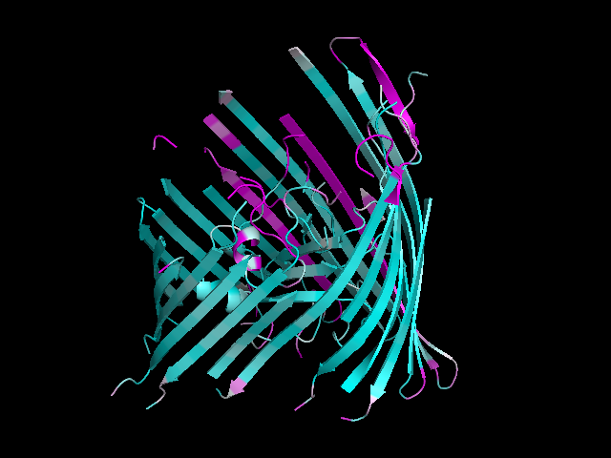

### Cluster71, 1T16 as target, 3BS0 as template

Identity with template is 12%  
107 of 194 (55%) of sequences in this cluster have at least this much sequence identity with the template  
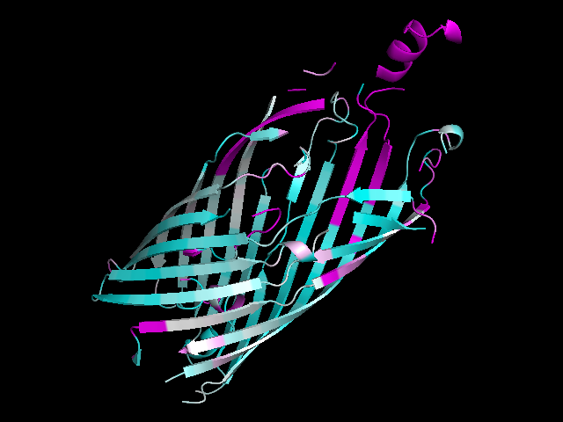

### Cluster73, 2MPR as target, 1A0S as template

19% sequence identity between target and template.  
18 of 51 sequneces in this cluster (35%) have this sequence identity or more with the template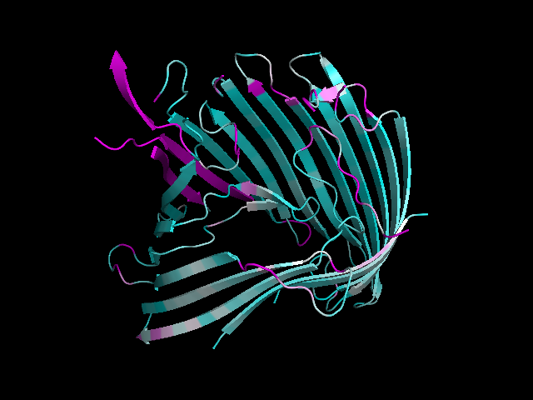

### Cluster99, 1PHO as target, 2J1N as template

Identity with template is 56%.  
17 out of 77 (22%) of sequences in this cluster have at least this much sequence identity with the template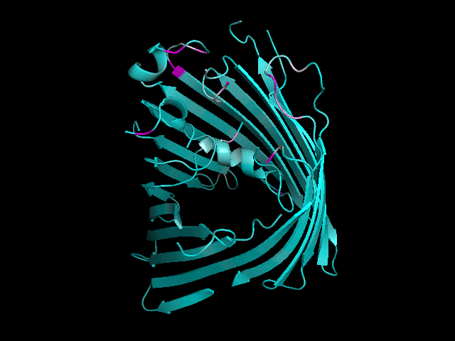

### Cluster99, 2OMF as target, 2J1N as template

Identity with template is 56%  
17 out of 77 (22%) of sequences in this cluster have at least this much sequence identity with the template